Create application specific folder and **TestLab** directory only.

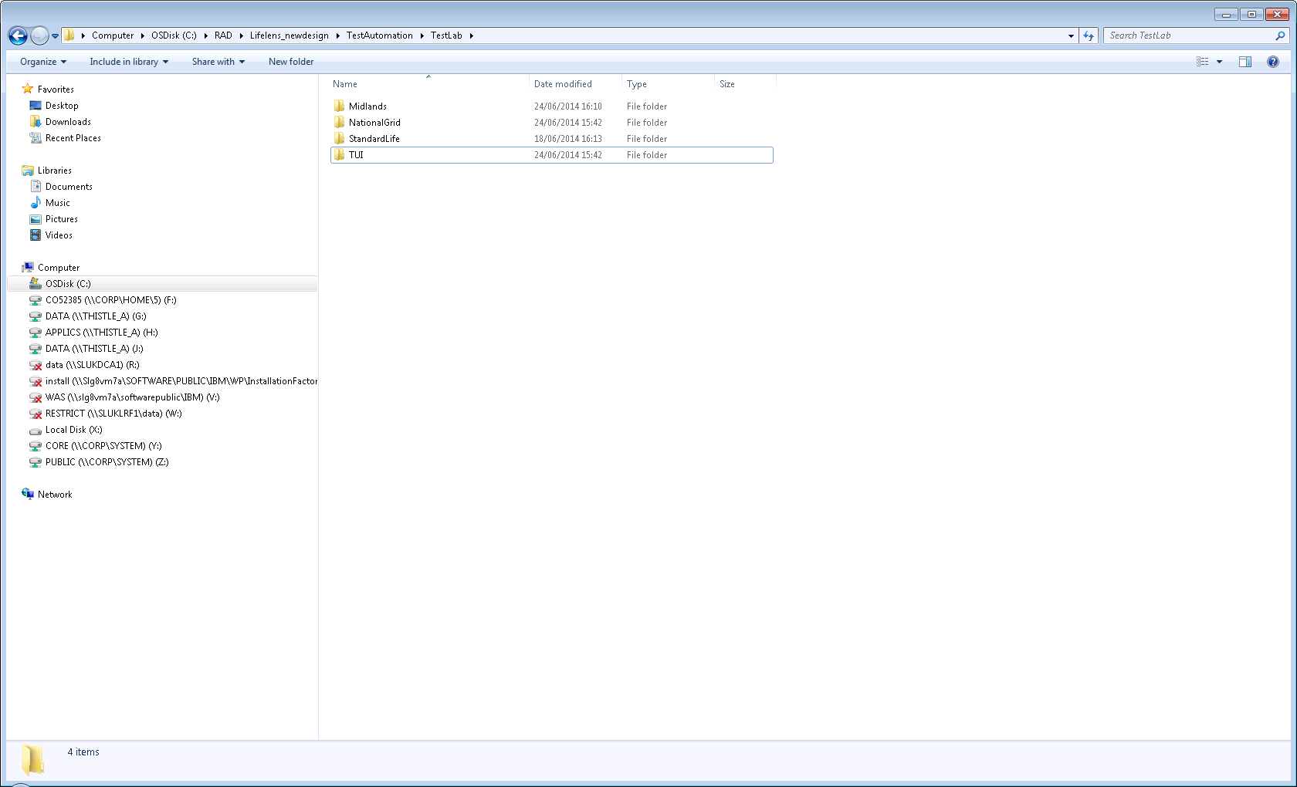

Copy test scripts and test data file into respective application folder.

**Note:** Test data file name needs to be constant between all the applications even though the data is different. Eg. Testdata.xlsx (Whatever value you are giving in the config.properties file).

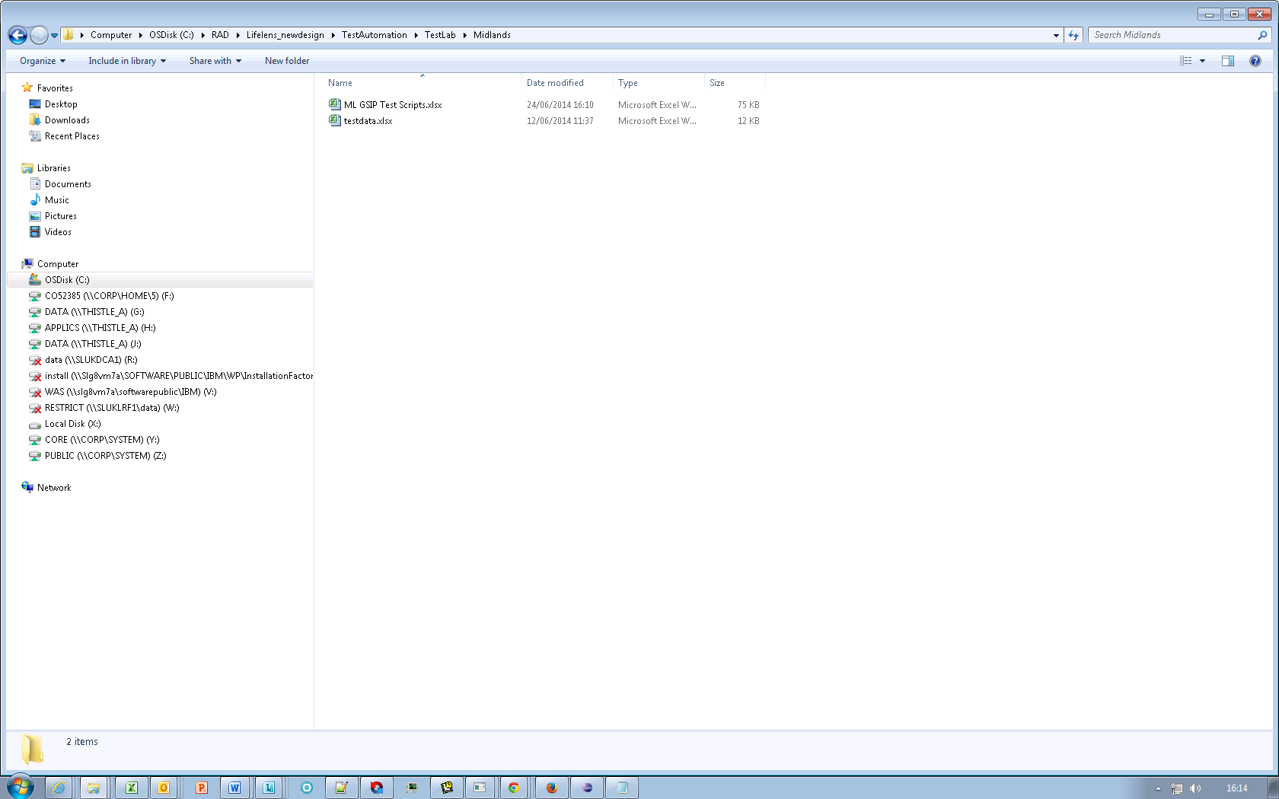

* In local you can give the path that you like to save your test scripts and results using the property in config.properties file **testRunFolder.**
* Possible values that can be assigned to **testlab** property in config.properties file are Midlands, NationalGrid, StandardLife,TUI (if these folders are exist).
* If you create any new folders under TestLab directory you can assign those names to testlab property.
* We can test multiple application in a single run by appending those application names separated by “**;**” and assign to testlab property. E.g. testlab=TUI;Midlands; NationalGrid

Once you run the tests (build.xml) your scripts will be copied in to the directory that you assigned to the property **testRunFolder** as

**testRunFolder/**TestLab/<list of folders that were assigned to **testlab** property by appending run time stamp>/*.xlsx

E.g. If testRunFolder **= F:/Lifelens_Automation_TestRuns** and testlab=**Midlands;TUI**

Then test scripts will be copied in to

**F:/Lifelens_Automation-TestRuns/TestLab/ Midlands_<run timestamp>**

**F:/Lifelens_Automation-TestRuns/TestLab/TUI_<run timestamp>**

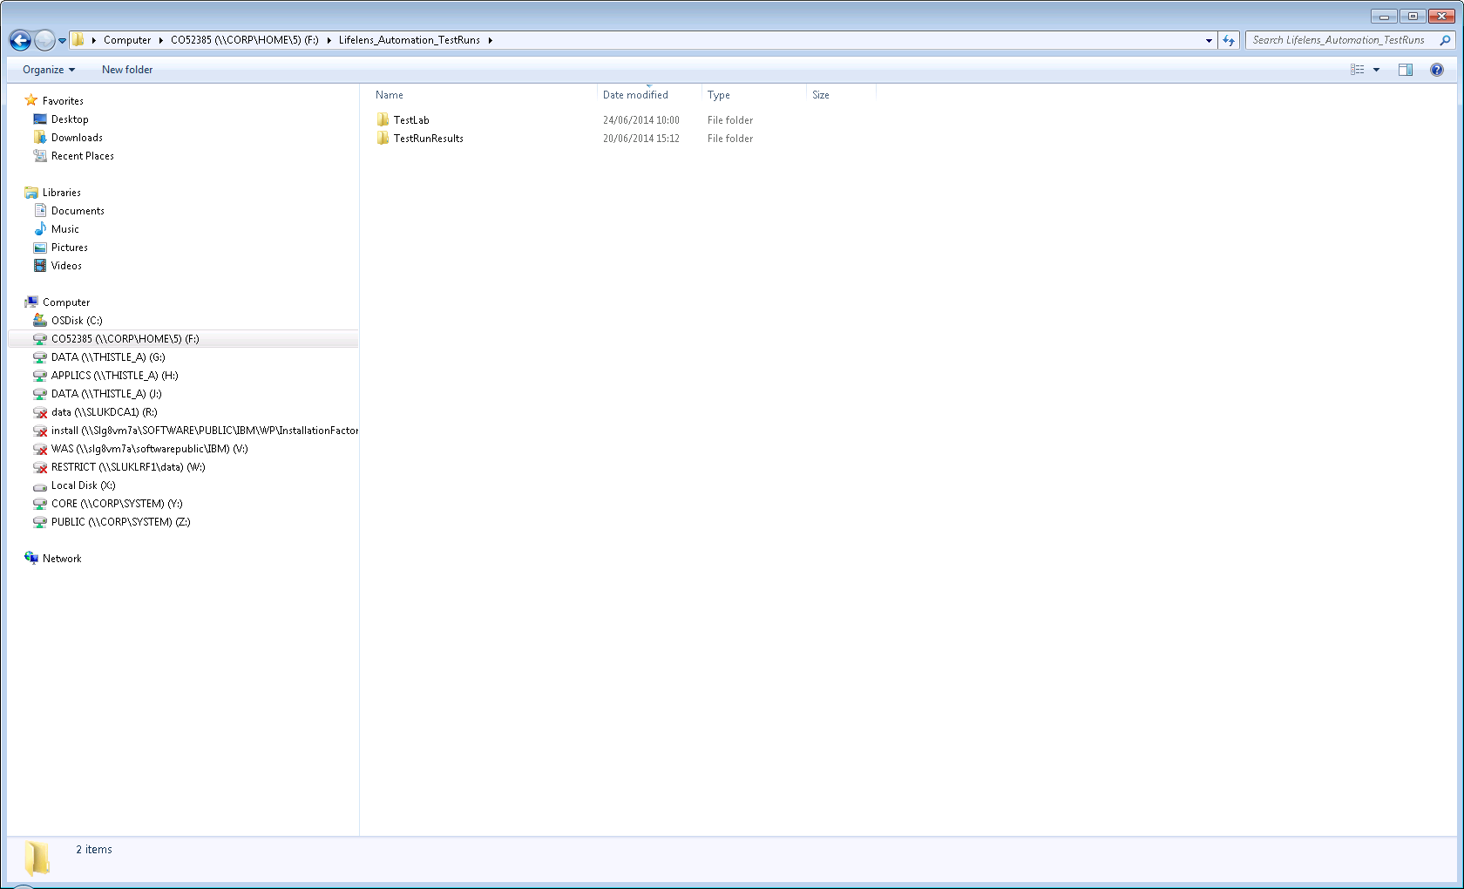

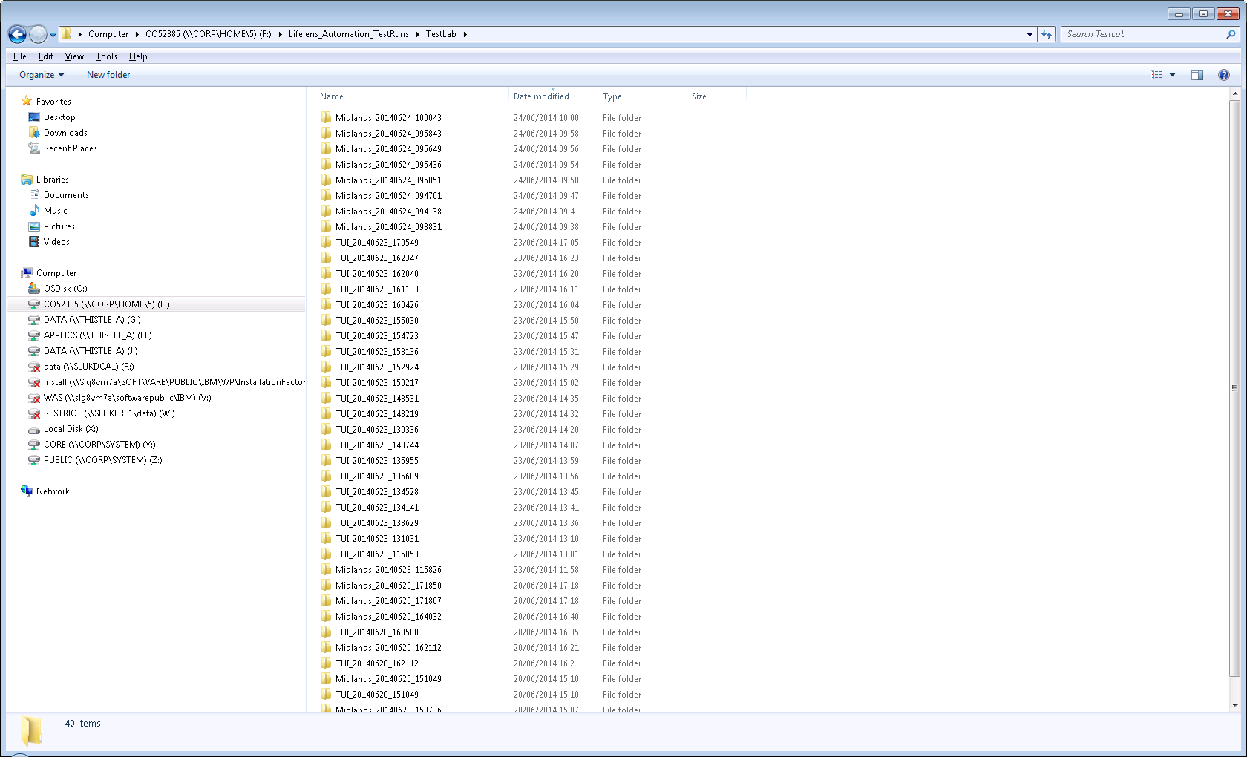

Screenshots will add to **F:/Lifelens_Automation-TestRuns/TestLab /<application_run timestamp> /Screenshots folder**

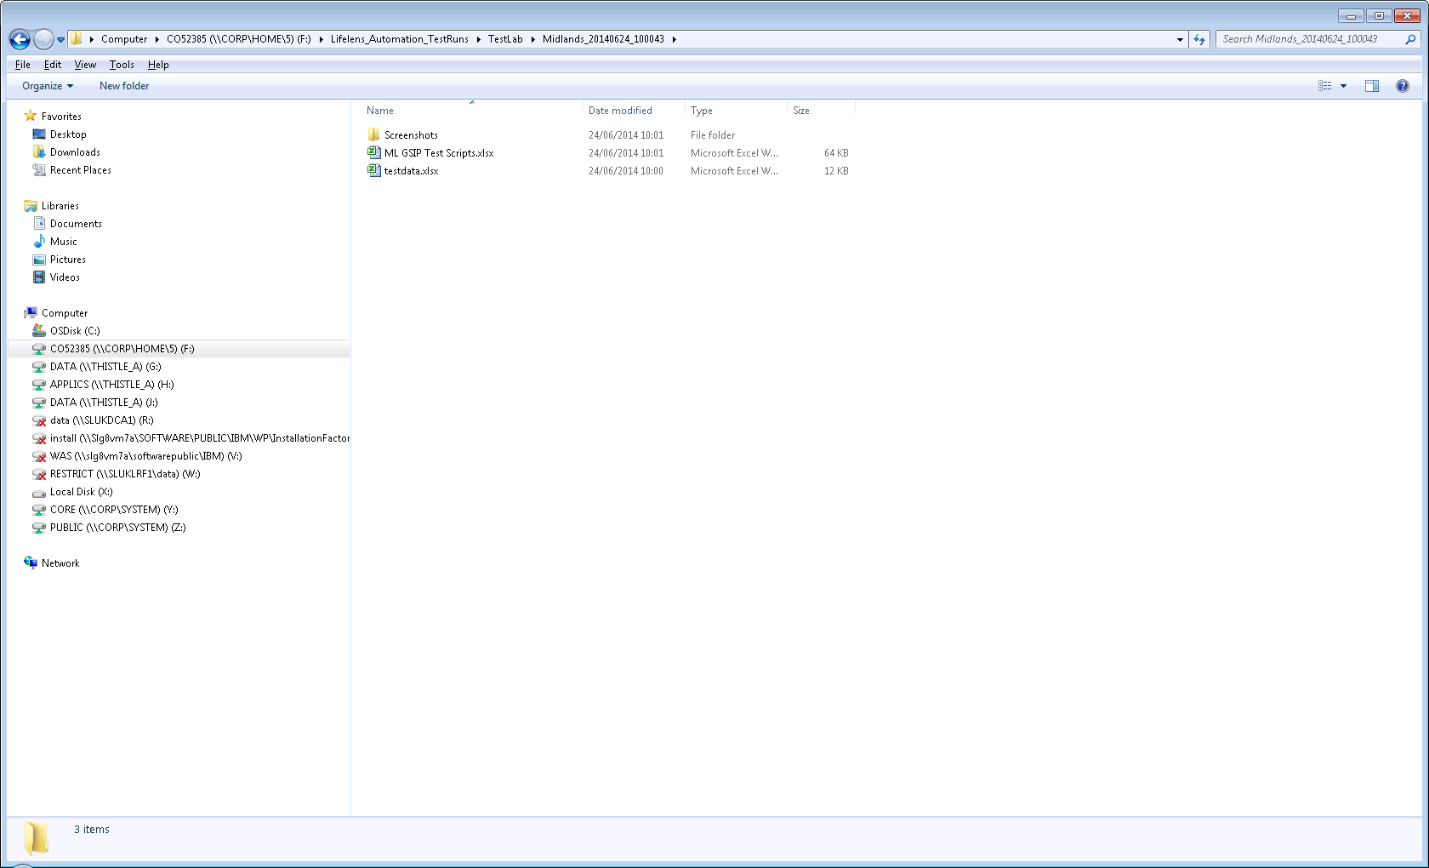

TestNG results and reports will add to

**F:/Lifelens_Automation-TestRuns/TestRunResults/TestNGResults/TestNGResult_At_<run timestamp>**

**F:/Lifelens_Automation-TestRuns/TestRunResults/TestReports/TestReport_At_<run timestamp>**

